

Publishing Accessibility Action group

ANNUAL REPORT 2024

## Contents

* [Introduction to the PAAG annual report 2024](#_Introduction_from_the_1" \o "Introduction to the PAAG annual report 2024)
* PAAG Working Group members
* [Acknowledgements](#_Acknowledgements_1" \o "Acknowledgements)
* [Accessible Publishing Charter](#_Charter" \o "Accessibility Publishing Charter)
  + [Charter signatories](#_Charter_signatories" \o "Charter Signatories)
  + [Charter allies](#_Charter_allies" \o "Charter Allies)
* [PAAG Community](#_Community" \o "PAAG Community)
  + [Website](#_Website" \o "PAAG Website)
  + [LinkedIn](#_PAAG_LinkedIn_Group" \o "PAAG LinkedIn Group)
  + [Mailing list](#_PAAG_Mailing_List" \o "PAAG Mailing List)
  + [Meetings](#_PAAG_Mailing_List" \o "PAAG Mailing List)
  + [Events](#_Events_1" \o "Events)
* [Special theme: PAAG-Con 2024](#_Special_theme:_PAAG-Con" \o "Special Theme: PAAG-Con 2024)

## Introduction from the PAAG chair

Welcome to the Publishing Accessibility Action Group annual report for 2024.

The Publishing Accessibility Action Group (PAAG) continues to offer support to the publishing community in implementing accessible publishing workflows and making content available to all.

The year has seen PAAG go from strength to strength. PAAG Accessible Publishing Charter members now include over 60 publishers and organisations from across the publishing ecosystem. Our LinkedIn group and the newly launched PAAG mailing list continue to offer information and opportunities to engage with the community.

The publishing year was dominated by preparation for the forthcoming European Accessibility Act (28 June 2025) and efforts to understand the impact and possibilities offered by AI. In response to these pressures, we were delighted to hold the inaugural [PAAG-Con](https://www.paag.uk/paag-con-2024/) accessible publishing conference in Oxford. The event was a fantastic success and proved to be a great opportunity to get together as a community and share ideas and best practices.

We hope you enjoy taking a look back over the year in this annual report. The PAAG community will continue to be at the forefront of accessible publishing in 2025 and we look forward to working with you all over the next 12 months.

Stacy Scott

*Chair of the Publishing Accessibility Action Group and Head of Accessibility at Taylor & Francis Group*

Explore Stacy’s article: [The Critical Role of Allyship and Community in Accessible Publishing](https://inclusivepublishing.org/blog/the-critical-role-of-allyship-and-community-in-accessible-publishing/)



The objective of the PAAG is to embed accessible practices throughout the publishing ecosystem to ensure that all content and reading systems are designed to be inclusive and user-focused.

## PAAG Working Group members 2024

The PAAG Working Group acts as a steering committee for PAAG. Led by Stacy Scott, Head of Accessibility at the Taylor & Francis Group, the working group gets together on a regular basis to discuss and implement initiatives. If you would like to join and contribute to the working group, please contact the chair via the [PAAG LinkedIn Group or the PAAG mailing list](https://www.paag.uk/paag-mailing-list/).

In 2024, the PAAG working group members included:

* Stacy Scott, Taylor & Francis. Stacy is the Chair of the Publishing Accessibility Action Group
* Sarah Hilderley, DAISY
* Richard Orme, DAISY
* Simon Mellins, Simon Mellins Consulting
* Rebecca Felton, Hachette
* Jenny Cundill, Quarto
* Leanne Dobson, Frontiers
* Ken Jones, Circular Software
* Huw Alexander, textBOX

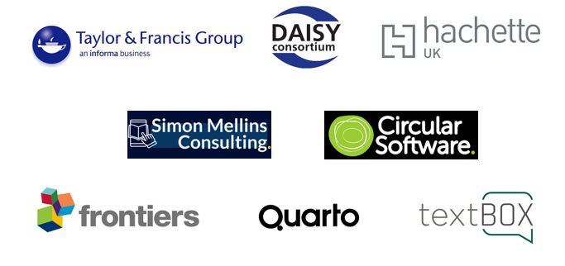

## Acknowledgements

The Publishing Accessible Action Group are very grateful for the continued support of the [UK Association for Accessible Formats](https://www.ukaaf.org/) for their generosity in supporting the creation and maintenance of the PAAG website, [textBOX](https://www.textboxdigital.com/) for supporting the PAAG mailing list, and the [IPG](https://www.independentpublishersguild.com/Default.aspx) for their invaluable help in making this year’s PAAG-Con possible

[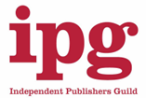](https://www.independentpublishersguild.com/Default.aspx)[](https://www.textboxdigital.com/)

[](https://www.ukaaf.org/)

## Accessible Publishing Charter

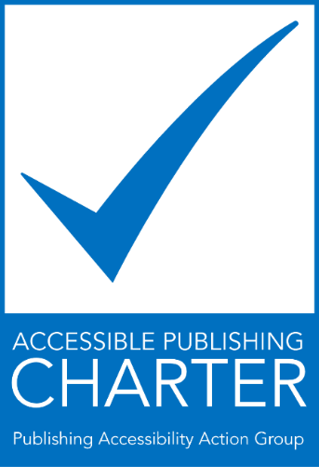

The Accessible Publishing Charter was launched in 2023 and encourages publishers and organisations to sign up to the charter and support the development of accessible publishing across the industry. The Charter can be signed by publishers and publishing allies (vendors in the wider publishing industry).

The growing availability of ebooks and other digital publications provides an unprecedented opportunity for persons with print disabilities to enjoy access to mainstream content at the same time, in the same format and at the same price as other readers. UK publishers and authors are eager to explore and develop the advantages that ebooks offer and, in so doing, reach more readers. Ensuring that ebooks are fully accessible, however, will only happen if publishers, authors, developers, platforms, and other stakeholders focus on this issue at a practical level.

Our objective is to make our content accessible to all and to aid others in this endeavour.

The signatories to the Accessible Publishing Charter commit to the following 10 goals:

1. Raising awareness among, and providing training for, relevant staff.
2. Nominating a company “accessibility champion” who can bring together key stakeholders to discuss potential accessibility improvements and act as a liaison for all accessibility information.
3. Publishing our accessibility policy on our website, including our commitment to this charter.
4. Designating and publicising a point of contact in our organisation to assist persons with disabilities to access alternate formats of our content.
5. Partnering with national and international organisations that provide support for the availability of publications in accessible formats.
6. Incorporating appropriate accessibility features within our digital publications and platforms, according to the web content accessibility guidelines and other appropriate accessibility standards.
7. Advocating for accessibility standards and collaboration throughout the publishing supply chain from author to reader.
8. Utilising the accessibility metadata opportunities available to aid with the discovery of accessible content.
9. Testing and validating content to ensure it is usable by people with print disabilities. Ideally this would include testing by persons with lived experience.
10. Monitoring our progress in this area and regularly assessing the accessibility of our digital publications and platforms.



### Charter signatories

There are 18 publishers signed up to the PAAG Accessible Publishing Charter. 4 publishers signed up in 2024 (an increase of 29%)

* 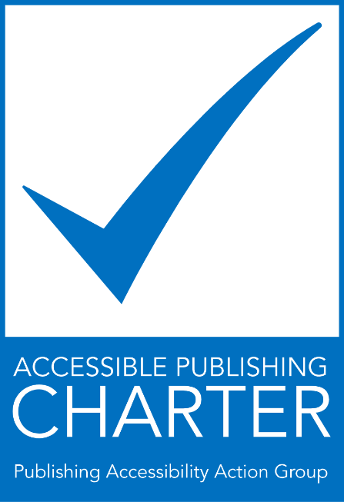[Bloomsbury](https://www.bloomsbury.com/ca/discover/bloomsbury-digital-resources/librarian-resources/accessibility/)
* [Cambridge University Press & Assessment](https://www.cambridge.org/)
* [Edward Elgar Publishing Ltd](https://www.e-elgar.com/)
* [Elsevier](https://www.elsevier.com/about/accessibility)
* [Hachette UK](https://www.hachette.co.uk/landing-page/hachette/accessibility/)
* [HarperCollins Publishers](https://www.harpercollins.com/pages/values-commitments)
* [Kogan Page](https://www.koganpage.com/page/accessibility)
* [Leamington Books](https://leamingtonbooks.com/)
* [Macmillan Learning](https://www.macmillanlearning.com/college/us)
* [McGraw Hill](https://www.mheducation.co.uk/about/accessibility-policy)
* [Pan Macmillan](https://www.panmacmillan.com/)
* [Penguin Random House](https://www.penguin.co.uk/)
* [Pottermore Publishing](https://www.pottermorepublishing.com/accessibility-statement/)
* [Princeton University Press](https://press.princeton.edu/)
* [Royal Society Publishing (The)](https://royalsociety.org/journals/)
* [Sage](https://us.sagepub.com/en-us/nam/home)
* [Springer Nature](https://www.springernature.com/gp/info/accessibility)
* [Taylor and Francis](https://taylorandfrancis.com/about/corporate-responsibility/accessibility-at-taylor-francis/)

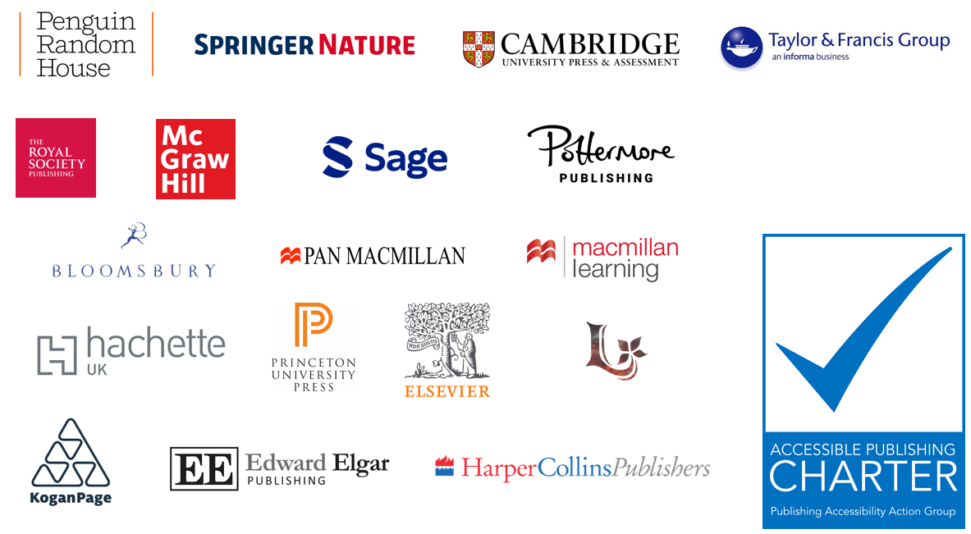

### Charter allies

43 organisations have signed the Accessible Publishing Charter as allies. 19 allies have signed up in 2024 (a rise of 80%):

* [Amnet](https://digita11y.amnet.com/)
* [AulaSIC](http://a11y.aulasic.org/)
* [bookcareers](https://www.bookcareers.com/)
* [BookMachine](https://bookmachine.org/)
* [BooksoniX](https://www.booksonix.info/)
* [Browns Books](https://www.brownsbfs.co.uk/)
* [Calibre Audio](https://calibreaudio.org.uk/)
* [Cenfor International](http://www.cenfor.net/)
* [Clarivate](https://support.proquest.com/s/article/Accessibility-Directory?language=en_US)
* [codemantra](https://codemantra.com/)
* [Colibrio Software AB](https://www.colibrio.com/)
* [Connect Design Solutions](https://iwanttoconnect.co.uk/)
* [Copyright Licensing Agency (CLA)](https://www.cla.co.uk/)
* [CPI Group UK](https://www.cpi-print.co.uk/)
* [DAISY Consortium](https://inclusivepublishing.org/)
* [EDItEUR](https://www.editeur.org/)
* [eLaHub](https://www.elahub.net/)
* [Flexedo](https://www.flexedo.com/)
* [Fondazione LIA](https://www.fondazionelia.org/en/)
* [Glassboxx](https://glassboxx.com/)
* [Haremi](https://www.haremi.co.uk/)
* [iAccessDigital](http://www.iaccessdigital.co.uk/)
* [Independent Publishers Guild (IPG)](https://www.independentpublishersguild.com/)
* [Ingram Content Group](https://www.ingramcontent.com/)
* [Inspired Search & Selection Ltd](https://www.inspiredselection.com/)
* [ISI](https://www.isicrunch.com/)
* [Just Content](https://www.justcontent.co.uk/)
* [Lapiz Digital Services](https://www.lapizdigital.com/)
* Laura Brady Consulting
* [Lumina Datamatics](https://www.luminadatamatics.com/)
* [Publishing Ireland](https://www.publishingireland.com/)
* [Publishing Scotland](https://www.publishingscotland.org/)
* [Refreshing Publishing](https://www.refreshingpublishing.com/)
* [Royal National Institute of Blind People](https://www.rnib.org.uk/) (RNIB)
* [RNIB Bookshare](https://www.rnibbookshare.org/cms/)
* [Share the Vision](https://readingsight.org.uk/)
* [Simon Mellins Consulting Ltd](https://www.simonmellins.com/)
* [textBOX](https://www.textboxdigital.com/accessibility)
* [Typeflow](http://typeflownyc.com/)
* [UK Association for Accessible Formats](https://www.ukaaf.org/) (UKAAF)
* [VitalSource Technologies](https://get.vitalsource.com/)
* [Westchester Education UK and International](https://westchestereducation.co.uk/)
* [Westchester Publishing Services UK](https://westchesterpublishingservices.co.uk/)

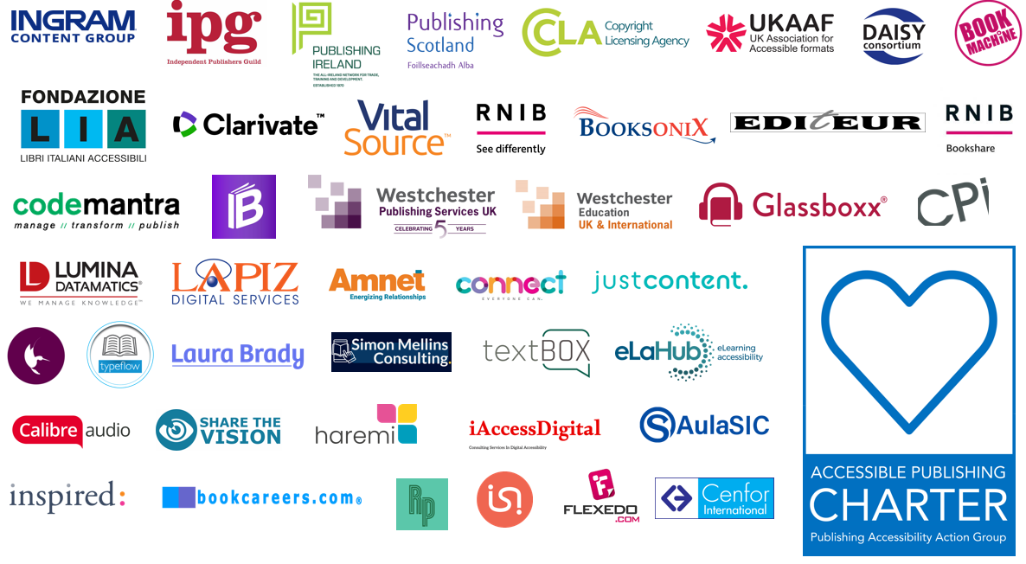

## The PAAG Community

The PAAG community has continued to develop in 2024 with an expansion of the website resources pages, the LinkedIn group attracting 464 members, bi-monthly meetings, a mailing list with 150 members, a range of presentations across industry events, and the inaugural PAAG-Con.

### PAAG Website



The PAAG website provides a wide range of resources for publishers seeking to implement accessible publishing programmes.

The website explores the business case for accessible publishing and provides the answers to frequently asked questions about accessible publishing. The resources pages cover a wide range of topics including:

* **Alt text**: creating image descriptions for all types of content.
* **Assistive technology**: including screen readers.
* **Accessible formats**: including, EPUB, PDF, and Microsoft products.
* **Metadata**: information about metadata including ONIX and Thema.
* **Accessibility organisations and advocates**: a list of national and international organisations working in the accessibility field.
* **Legal regulations and guidelines**: including WCAG, PSBAR, Section 508, Marrakesh, and a comprehensive list of articles and resources about the European Accessibility Act (EAA).
* **Testing and certification**: including the Accessible Books Consortium, Global Accessible Accreditation from Benetech, Fondazione LIA, and the ASPIRE accessibility statement review service.
* **Accessibility tools and solutions**: guides for accessibility tests and useful tools to help with the process including DAISY Ace.
* **Training and learning**: a selection of resources for training purposes and learning more about accessible publishing including webinars and courses.

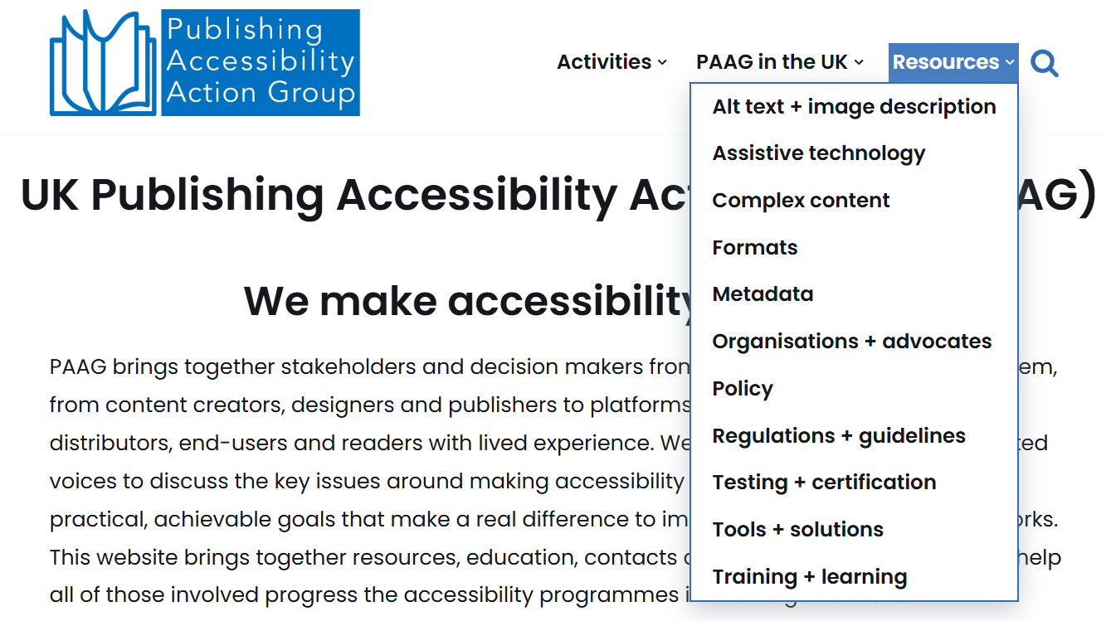

The PAAG website has been viewed by nearly 10,000 visitors from 91 countries in 2024, illustrating the vibrant interest in developing accessible publishing programmes across the world.

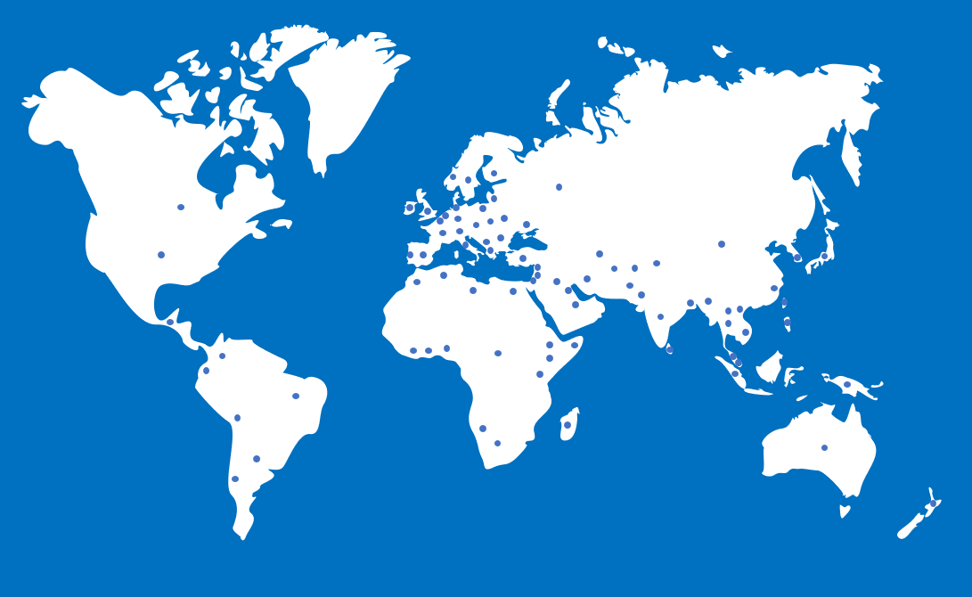

The PAAG website is kindly supported by UKAAF.

[](https://www.ukaaf.org/)

### PAAG LinkedIn Group

The PAAG LinkedIn group was launched in early 2023 and now includes 464 members, an increase of 110% in 2024 (244 additional members). The group acts as a forum for sharing news and information, and for discussing and implementing accessible publishing. The group contains a wide variety of members from across the publishing community, including an international range of publishers, ebook platforms, technology vendors, academic institutions, and accessibility advocates.

The [LinkedIn group](https://www.linkedin.com/groups/12649969/) welcomes anyone interested in accessible publishing to join the group.

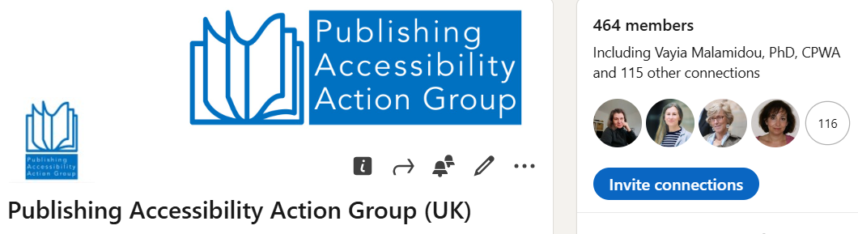

### PAAG Mailing List



The PAAG mailing list launched in 2024 and now has a bustling membership of 250 participants. The list acts as a forum for member questions and the sharing of ideas and advice around accessible publishing.

Topics covered in the forum this year include:

* Fixed page layouts
* Complex images
* European Accessibility Act
* Accessibility statements
* Accessible video
* Adobe InDesign
* Alt text for linguistic trees
* Accessible maths
* Large Print
* RNIB Bookshare
* Non-English language alt text
* User testing groups
* Alt text style guides
* Non-Roman script languages

Anyone interested in accessible publishing can sign up to the mailing list via the [PAAG website](https://www.paag.uk/paag-mailing-list/).

The PAAG mailing list is kindly supported by textBOX.

[](https://www.textboxdigital.com/)

### PAAG Meetings



5 PAAG meetings have taken place in 2024 (plus PAAG-Con). The brief agendas from each meeting are listed below and outline the range of diverse topics addressed by the group this year.

**28 March 2024**

* APACE project
* PAAG annual report 2023
* Feedback on LBF
* Alt text discussion

**30 May 2024**

* Large print: challenges and solutions
* Fixed layout EPUBs
* PAAG-Con: update

**25 July 2024**

* STEM and Math notation: approaches, solutions, and challenges
* End-user experience demonstrations
* Accessible Music

**19-20 September 2024**

* PAAG-Con

**10 October 2024**

* Reflections on PAAG-Con

**28 November 2024**

* Reflections from the Frankfurt Book Fair
* Adobe panel follow-up
* APACE project update
* EAA and the implications on Higher Education
* ABC award finalists

### Events



PAAG members organised and participated in a range of events and conferences during 2024 including the following:

* IPG Spring Conference (February)
* BookMachine: Putting Accessibility into Practice (February)
* London Book Fair 2024 (March)
* CSUN (March)
* ALPSP University Press Redux 2024 (May)
* Why and How – An Introduction to Image Description for Publishers (May)
* Countdown to EAA Webinar Series: Technical Approaches to Upgrading the Backlist (May)
* Countdown to EAA Webinar Series: Accessibility Testing (June)
* BIC Brunch: The EAA, Getting Back to Basics, The Legalities (July)
* Countdown to EAA Webinar Series: Reading Solutions (July)
* PAAG-Con 2024 (September)
* Countdown to EAA Webinar Series: Image Descriptions (September)
* Frankfurt Book Fair 2024 (October)
  + The Accessibility Era: Are you Ready For It?
  + Adobe InDesign: Progress Made Towards Mainstreaming Accessibility
* BIC Brunch: EAA: Metadata (September)
* IPG 2024 Autumn Conference (September)
* BIC Brunch: EAA: Digital Content (October)
* Access Higher Ground (November)
* Jisc: The EAA: What Does it Mean for UK Higher Education Providers? (November)
* BIC Brunch: EAA: Alt Text For Digital Books (November)
* The University of Westminster Accessibility Symposium (December)
* BIC Brunch: EAA: Fixed Layout (December)

## Special theme: PAAG-Con 2024

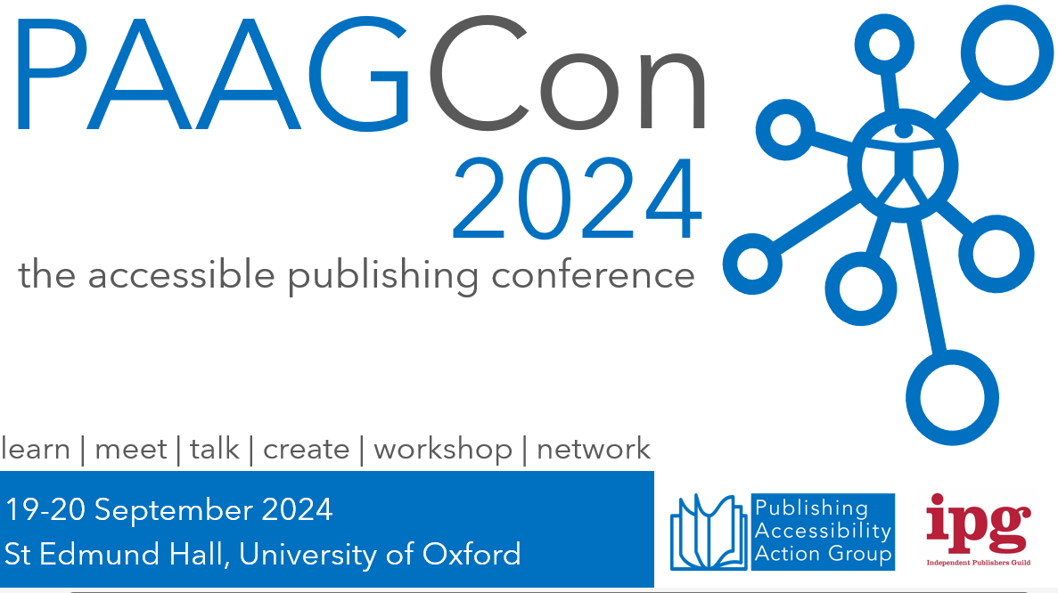

### Introduction

The inaugural PAAG-Con took place at St. Edmund’s Hall in Oxford on 19-20 September 2024. Over 80 delegates took part in the successful event, which brought together a host of experts and participants from across the publishing spectrum.

With the European Accessibility Act looming on the horizon in June 2025, PAAG-Con was a fantastic opportunity to share knowledge and ideas to help the publishing community to meet the new regulations. The accessible publishing community is a unique, collaborative environment and the 2-day conference was both enjoyable and informative and a great opportunity to meet old and new colleagues alike.

Thank you so much to all our speakers, to the IPG for sponsoring the event, and particularly to the conference committee who volunteered the time to making PAAG-Con such a success.

Read the [Inclusive Publishing article on PAAG-Con 2024](https://inclusivepublishing.org/blog/paagcon-2024/).

### PAAG-Con Agenda

A snapshot from the back of the room captures Stacy Scott addressing a room full of delegates and welcoming everyone to PAAG-Con, alongside Simon Mellins and Richard Orme.


The agenda for PAAG-Con 2024 covered the following topics.

* Accessible Publishing 101.
* Demystifying ARIA and WCAG versions; Accessibility Metadata in Practice.
* Law and Order; Accessibility and eCommerce.
* Techniques for STEM and other complex materials.
* Winning Business Cases for Inclusive Publishing; Putting ideas into practice.
* Validation and testing; HTML, EPUB and PDF compared.
* Braving the Backlist: Practical approaches for dealing with accessibility’s biggest elephant.
* Personas and UX.
* Beyond ebooks.
* Where the rubber meets the road: a11y support in reading apps.
* Real world approaches for image descriptions; Managing and applying AI for accessibility.

Explore the [full agenda on the PAAG website](https://www.paag.uk/paag-con-2024-agenda/).

### PAAG-Con Feedback

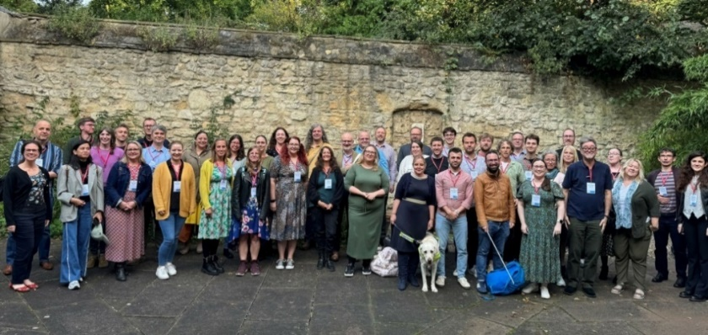



PAAG-Con was the most useful publishing conference I have been to, and it has given me fresh insight into accessible publishing. I have taken away invaluable information and insight into how we can improve our books to make them useable by everyone.



Thank you so much for such an informative and valuable conference. I appreciate everyone who took the time to share their accessibility journeys and experiences. I would certainly hope to be able to contribute more to this incredible community in the future.



It was a really helpful event, and I appreciated that everyone was so friendly and made everyone else feel so welcome. I learnt a lot and it was really useful to talk face-to-face with others in the same boat!



Thank you for organising PAAG Con 2024. It was as enjoyable as it was informative. I hope that this invaluable opportunity to meet, share and learn is repeated next year.

### Thank you

A special thank you to the conference committee for volunteering their services and making PAAG-Con 2024 such a success.

* Ken Jones, Circular Software
* Jenny Cundill, Quarto
* Leanne Dobson, Frontiers
* Charly Salveson-Ford, IPG
* Simon Mellins, Simon Mellins Consulting
* Richard Orme, DAISY
* Stacy Scott, Taylor & Francis

PAAG-Con 2024 was kindly supported by the IPG.

[](https://www.independentpublishersguild.com/)



© Publishing Accessibility Action Group, 2024

First published 2024.

 

Attribution 4.0 International (CC BY 4.0).

This work is licensed under Creative Commons Attribution 4.0 International.